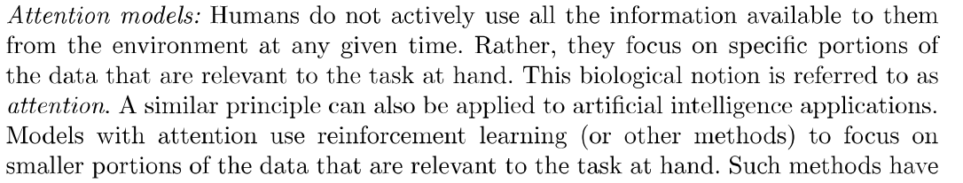

Fig: Resolutions at different regions of Eye

Recurrent Models of Visual attention

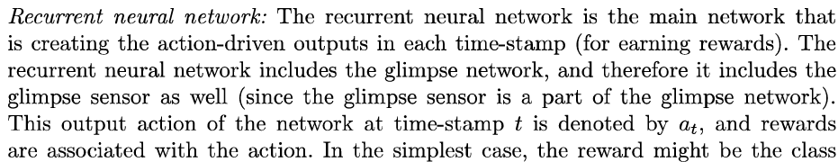

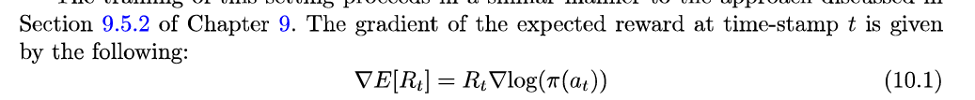

Image Captioning

Fig: Visual attention in Image captioning

Generative Adversarial Networks (GANs)

Two types of learning models used for creating adversarial Nwtworks are:

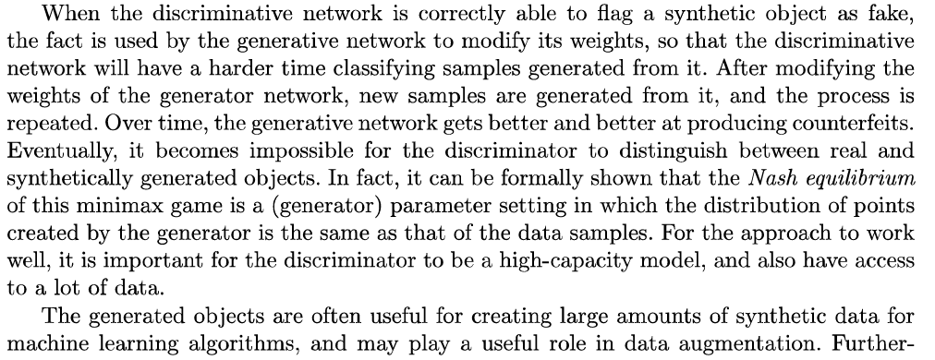

Training GANs





